BELMORE NORTH PUBLIC SCHOOL
201 Burwood Road, BELMORE NSW 2192
Phone: 9750 0652
Fax: 9758 1109
Email: belmorenth-p.school@det.nsw.edu.au
Website: www.belmorenth-p.schools.nsw.edu.au
2023
Belmore North Public School Newsletter
Term 4 Week 5
Principal’s Message
Dear Parents and Carers
This is a very busy time of year for me as I reflect on the school year and make necessary adjustments for 2024. Throughout 2023, Belmore North Public School has increased student enrolments by approximately 40. We are steadily growing; as such, necessary safety, supervision, and wellbeing adjustments need to be made to accommodate our rising population. Commencing 2024, students will have two breaks throughout the day:
Break 1 – Lunch 11.00am – 11.35am – 35 minutes.
Break 2 – Afternoon Tea 1.25pm – 2.00pm – 35 minutes.
70-minutes total
The new play times allow evenly distributed breaks throughout the school day. The current play time model is:
Break 1 – Recess 11.00am – 11.20am - 20 minutes.
Break 2 – Lunch 1.00pm – 1.50pm - 50 minutes.
70-minutes total
Current data trends suggest most issues on the playground occur during the second half of lunch break (1.25pm – 1.50pm). The reallocation of time allows students to have enough time to eat, play and use the toilets as needed. Importantly, it will reduce the amount of time students are playing in peak heat during spring and summer.
As of 2024, the Support Unit classrooms will be reallocated across the school. This will further embed a culture of inclusion, collaboration, and student wellbeing. Support Unit classes will all neighbour a mainstream class. I am excited to take this ‘big step’ at Belmore North Public School and I am looking forward to shared teaching and learning opportunities through integration programs. The current Support Unit classes will be repurposed to support student wellbeing programs and teacher learning spaces.

New enrolments – Kindergarten
If you are planning to enrol your child into Kindergarten for 2024, please do so as soon as possible. This gives the teachers time to prepare for your child and place them in the most suitable class. If you are unsure if your child is ready to start school, you are welcome to book a time to speak to one of our staff about ‘student readiness’. Sometimes, holding your child back for one additional year is the best-start they can have to schooling. This provides your child an additional year to develop personal hygiene routines, social skills, emotional readiness, and essential expressive and receptive language.
Coeducational Schools:
The NSW Government has made a commitment that every student will have guaranteed access to co-educational public high schools by 2027.
My staff and I are available to talk through high school options and these changes with you. We will also continue to support your child, so they can understand the options available to them. If you would like to know more, please book a time to see me.
Staff Update:
Congratulations to Mr Nicholson and Ms Haddad who were successful in acquiring permanent positions at Belmore North Public School. Mr Nicholson is our new General Assistant who comes with many years experience with general maintenance and Work Health and Safety compliance. Ms Haddad is currently a relieving Assistant Principal with experience leading students, staff, and community initiatives. She is passionate about community engagement and is excited to start in 2024.
Upcoming Events:
Community Afternoon:
The P&C will be holding a sausage sizzle on Wednesday, 15th of November between 3.30pm and 5.30pm. Parents are encouraged to attend with their children for a fun afternoon of games and food. Children are NOT permitted to attend the event on their own. If your child is sent to the event unsupervised, you will be asked to collect your child from the front office. There will be NO teacher supervision between 3.00pm – 3.30pm. All students must go home at 3.00pm and return at 3.30pm with a parent or carer. Please use the RSVP note sent home last week to indicate your attendance. I am looking forward to seeing families on the day. This is a great opportunity for families to connect with one another and have a chat to our friendly teachers, school learning support officers and school administration staff.

Trivia Night
Trivia Night is the biggest community event of 2023. This is a time to connect with staff, parents, and the wider community for a fun night of food, raffles, and trivia. Please come along and help us celebrate Belmore North Public School’s growing community spirit and raise money to rebuild and refit the student accessible kitchen. Our students deserve a modern teaching and learning environment that is reflective of their needs. If you are unable to attend, you can support the cause by purchasing raffle tickets or making donations. The raffle ticket prizes are:
Strictly limited seating – You must RSVP by purchasing a $20 ticket at the front office as soon as possible.
- Sony PlayStation 5 – valued at $700
- Nintendo Switch - valued at $500
- Gift card - valued at $300
If you would like to purchase raffle tickets, please contact the school. Raffle ticket prices:
- $2 for 1 ticket
- $55 for 45 tickets
- $100 for 100 tickets

If you would like to donate prizes for the night, we are accepting chocolates, appliances, toiletries, textiles, tools, candles, and other similar items. Please ensure the items are new. Evey little bit goes a long way.
We are all looking forward to a fun night. Come along!

Sideshow Alley:
Year 5 and 6 students work collaboratively to host fun games and stalls for K – 4 students. The proceeds of the event go towards funding the Year 6 Farewell. Students are welcome to donate toys, lollies, stickers, stamps, and other similar items to help make their activity or stall enticing for others to engage with. Year 5 and 6 students are encouraged to start bringing in their donations to store at school. More information about Sideshow Alley is yet to come.
Restorative Teaching and Practice
Belmore North Public School’s Student Behaviour Management Implementation Plan has been under review throughout 2023. Through staff, student, parent and community collaboration, the Restorative Teaching / Restorative Practice model will lead student behaviour management. We are still using aspects of the Positive Behaviour for Learning model to set whole school learning expectations and rules; however, Restorative Teaching and Restorative Practice is what underpins our behaviour support.
The idea is to use both Positive Behaviour for Learning and Restorative Practice to create a multi-tiered system of student support. Below is a prototype of how the two systems will work at Belmore North Public School. The higher the tier, the higher the level of support the student requires to engage in safe learning practice at Belmore North Public School. Positive Behaviour for Learning is the foundation of behavioural expectations while Restorative Practice empowers students to take lead in actively solving their problems. Students take an empathetic stance when listening to their teachers and friends and use their developed emotional literacy to express their emotions more accurately. This is a life-long skill that I am proud to develop in young minds of the future. Currently, we have piloted the Restorative Practice model with select students and teachers which has been successful. Many students have reconnected with their peers by taking an empathetic stance to problem solving and worked collaboratively with teachers to set fair and achievable learning and behaviour goals.
Tier 1 – PBL  Setting up operational norms  Led by:  - Teacher | Setting whole school rules and expectations:  +Be Safe – Keep your hands and feet to yourself  +Be Respectful – Mouth closed and ears open when the teacher is speaking.  +Be a Learner – Do your best, ‘give it a go’
Tier 2 – Restorative Practice  Setting up communication norms  Led by:  - Teacher  - Student | Engage in restorative dialogue when faced with perceived conflict.  Discuss:  The past – “When did this start?”  The present – “What is happening now?”  The future – “What can you agree to?”
Tier 3 – Restorative Practice  Student led goals and consequences  Led by:  - Teacher  - Student  - Learning and Support Team  - Stage Supervisor | Hold students accountable for the goals they set.  “You agreed to share your ball with the other student, have you done that? what do you think the other students would say?”  “You acknowledged taking the ball from the other student, what is a fair consequence?”
“You agreed to keep your hands and feet to yourself, have you done that? Show me how you do that”.

“You agreed to pushing the other student, what is a fair consequence?”

“You agreed to work with the other student in your group, how have you done that? The other student has mentioned they feel excluded”.

“You admitted to ignoring the students’ point of view, what is a fair consequence?”
Tier 4 – PBL  Principal led goals and consequences  Led by:  - Learning and Support Team  - Stage Supervisor  - Principal | Consult with the student and parent to determine a fair consequence.  “Last week I spoke to you about your behaviour. I listened to your side of the story. You agreed to keep your hands and feet to yourself; however, you since hurt a student. You agreed to miss out on ten minutes of play time due to your behaviour. You have now hurt two students in one week. Here is a list of consequences I would like us to agree on today:  (Some options)  +Stay by a teacher’s side during play time  +Detention  +Write a letter of apology  +Miss out on the next class or school event  +Miss out on the next excursion  +Suspension

Each student behaviour or student welfare issue is unique; as such, will be managed in an appropriate way. The Restorative Practice model is adaptive which allows differentiated approaches to various situations.

Here are some examples of resources we are developing to underpin the restorative conversations staff will have with students. At the core of Restorative Practice, is rich vocabulary relating to empathy, emotions, and decision-making.
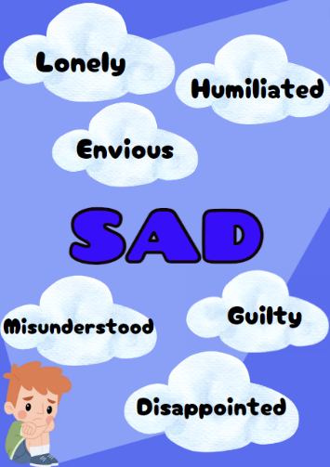
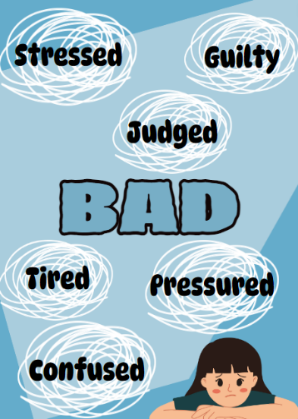
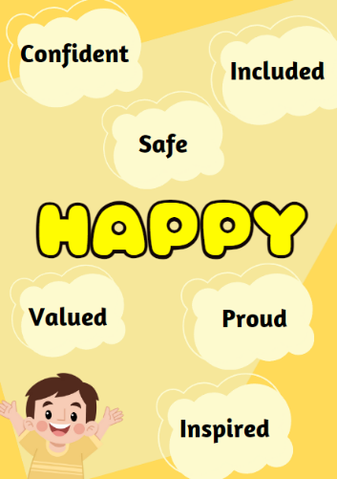
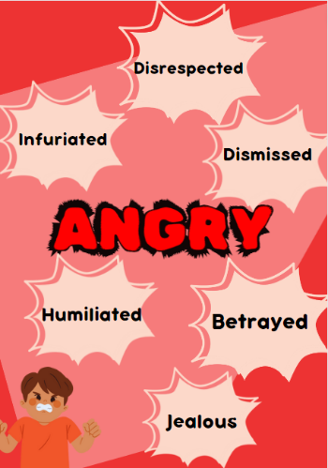

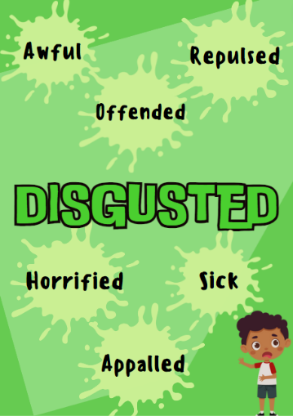
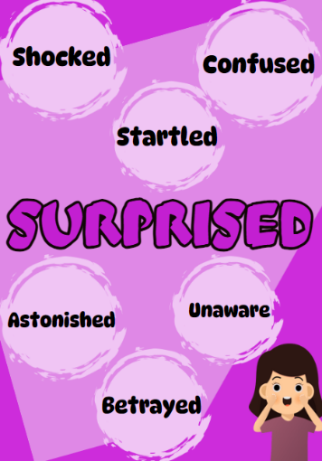
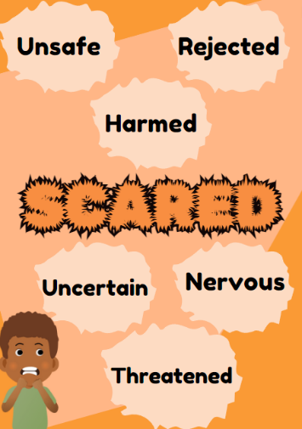

Student Lost Property / Lost Clothing
To reduce the growing stockpile of lost property outside room KP, Belmore North Public School will be disposing all unclaimed lost property fortnightly on even-week Thursdays. Parents are strongly encouraged to label their children’s belongings, including clothes, lunches boxes and drink bottles.
If you have any questions regarding school uniform, please contact the school.
Update to School Improvement Plan
Before the close of the academic year, I will be completing the Annual School Review. This is a time for me to reflect on the three focus areas of development for Belmore North Public School as decided by students, families, and teachers. This process guides schools in making relevant adjustments to goals for 2024. Below is a quick-reference guide to our current strategic directions:

Strategic Direction 1 | Strategic Direction 2 | Strategic Direction 3
Literacy and Numeracy Growth through Explicit Direct Instruction. | Student, Staff, Parent and Community engagement and wellbeing through Restorative Teaching and Restorative Practice. | School Processes and Products
2023 Goals and Achievements
- Growth in Student Literacy data  - Teacher and Leaders Professional Learning Plan  - School Leaders as Lead Learners  - Relaunch of Explicit Direct Instructions | - Deep analysis of current student wellbeing and welfare policies and procedures  - Explicit and Direct professional learning on Restorative Practice and Restorative Teaching  - Staff professional learning on Restorative Circles  - Increased parent engagement through P&C and open classrooms  - Community Events – Trivia Night, Community BBQ, Education Week | - School budget aligned to explicit teaching and learning resource expenditure.  - Work Health and Safety and student attendance protocols embedded in weekly communication meetings, leadership team meetings and team meetings.  - Update Student Reporting format for 2024

Class name / House Names
Commencing 2024, classes at Belmore North Public School will be given a unique ‘class name’. This is something many schools have adopted. Our school captains, Keith and Evie are doing an amazing job of presenting the class name options to each class and collecting votes. Class name options are:
- Space Theme
- Animal Theme
- Famous academics

Students will also vote on new ‘house names’. More information to come.
Attendance / Travel / Leave Request
Forward planning for 2024, please aim to book family travel during the school holidays. It is so important that students attend school each day. Everyday counts! I will be declining leave related to leisurely travel unless there are exceptional circumstances. If you would like to discuss this in greater detail, please book a time to meet with me.
Therapist supporting students.
Belmore North Public School affords our families the opportunity to have their NDIS therapist team work collaboratively with classroom teachers. If teachers are unable to accommodate the times in which therapist can access your child, they will be asked to reschedule. Therapist must work in line-of-sight to a teacher and compliment the teacher’s teaching programs. Therapists should not be withdrawing students from the classroom to complete unrelated tasks. Belmore North Public School has various therapists on site to support student needs. It can become challenging to have multiple therapists on-site at a time as it creates additional foot-traffic in the school and classroom, particularly in the Support Unit.

As we draw nearer to the end of the school year, I encourage parents to be mindful of sun safety for their child. Sunscreen, hats and water bottles are an important part of being sun-safe.

Stay safe and see you at the front school gate each morning.

John Pierre Kiraz
Principal – Belmore North Public School

